Portfolio Card (100 points)
Create a Web page (HTML5 + CSS3) that looks like the screenshot below:
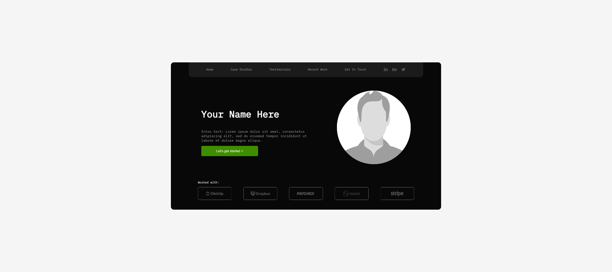

Output
The output should be valid HTML5 + CSS3 that implement the above web page.
- Use font 'IBM Plex Mono' – already imported in the CSS file.
- The site should open correctly in the latest version of Chrome

IMPORTANT: Do not change the structure of the provided exam resources. You may create files, but do not create new folders, rename existing ones, or move them to other directories.

Hints:
- Background and font colors: Use a color picker tool to identify the colors from the provided image and apply them to the frontend design.
- Icons: All required icons are available as images in the 'images' folder.

